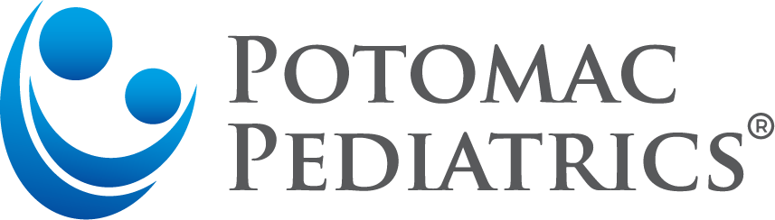

Annual Non-Covered Services Fee
Many services provided in our office are non-covered services. This means that insurance companies do not remit payment to our practice even if they are recommended by the American Academy of Pediatrics (AAP) and are legitimate medical codes. We believe every family should utilize all these services and have decided to charge a single annual fee of $110.00 per child, with a family maximum of $250.00. This fee ensures all patients have access to affordable quality care and services. This fee is billed annually in March.
The NCSF includes access to the following:
- FREE Classes/Seminars for every age group
- 1 paid ticket seminar per child annually.
  - Group nutrition session
  - Ancillary specialist seminar
- Discounted CPR certification course (Avg. of $30 cheaper than local courses)
- Completion of prescription refill requests without an office visit
- Unlimited medical record copies
  - Specialists
  - Legal Matters
  - Personal use
- CHADIS access for well-child examinations. CHADIS is an online tool used to screen your child for developmental delays and mood disorders. We encourage every family to utilize this service.
- Extended Evening and Weekend Hours - All after-hour patient responsibility balances from your insurance carrier are adjusted off.
- Comprehensive medical advice service during office hours.
- After-hours medical advice with staff triage nurses and providers.
- Medical Service Treatments (often not covered at 100% by insurances)
  - Annual vision screenings
  - Annual hearing screenings
  - Pulse oximetry
  - Fluoride Treatment
- Patient Portal Access
  - Request appointments
  - Message your provider
  - Request referrals
  - Medication refill requests
  - Access to patient medical records
- Live Chat for appointment scheduling and medical advice!
- InstyMeds- Access to fill prescription and over-the-counter medications in office.
- Insurance Claim Appeal/ Re-filing.
- Billing Summaries for FSA, HSA, tax, or personal purposes.
- Insurance account resolutions including working with your insurance company and HR specialists.
- Health Forms
  - Daycare, School, Sports, Camp, etc.
  - HIPAA compliant digital forms providing easy access, faster completion, and securely delivered right back to your email.

Updated 2/28/2022

