Returning to Potomac Pediatrics for COVID Testing?

If you have previously registered with Potomac Pediatrics for testing there is no need to go through the registration process again.
When you click the webpage link to register instead of filling in the information please instead select the option that says “returning? Log in” in the top right(as shown below) This will allow you to login to your account from last time and create an appointment.

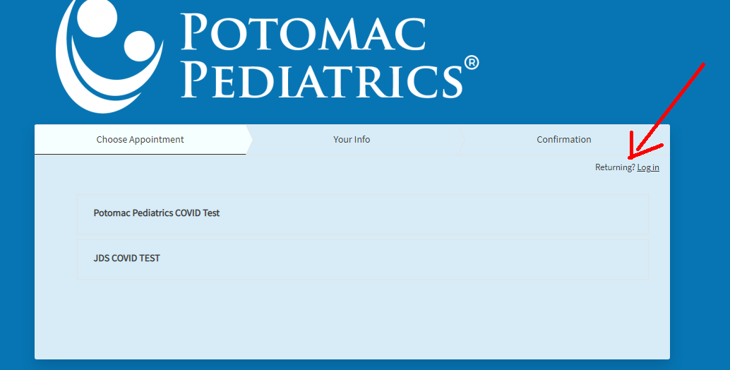

If you did not register last time when creating your appointment, please locate your confirmation email from the first test and click on “change/cancel appointment” this will bring you to a screen that looks similar to the one above and you will be able to register this way.

